# Infrared Non-Contact Forehead Thermometer

# Sejoy DET-306

# Instructions on switching between Forehead and Object Mode

**Forehead Mode**

* Press the power on button
* Set time/date etc. and device will default to Forehead mode on initial start up
* Forehead mode is active when picture of person is active on screen (refer to image below)

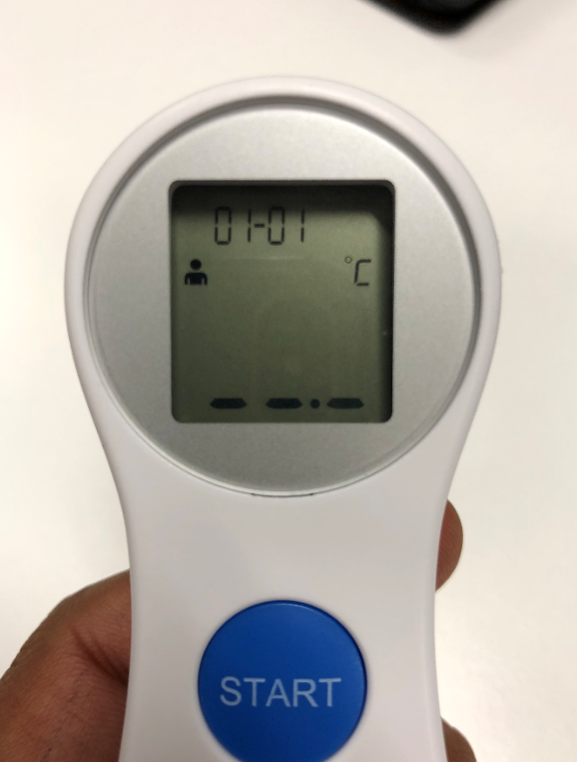

Forehead mode with image of person for taking reading from people

**Object Mode**

* Object mode is for taking temperature reading from inanimate objects
* To switch hold the Centre button down for 3 secs (refer to image below)
* DO NOT try reading human temperatures in this mode as it will not record correct temperatures
* To switch back to Forehead mode hold Centre button down for 3 secs again

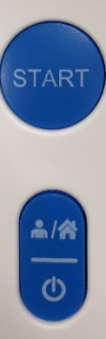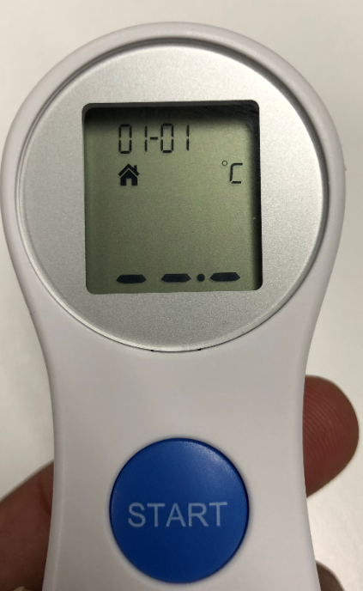

Object mode active with image of house for taking temperature readings from objects NOT PEOPLE

Hold it down for 3 secs. Changes mode to Object mode. Symbol of house will appear on the screen